|  |
| --- |
| **File-APP server shares v1.1** |

Preparations 1

Deploying AppServer 2

Deploying FileServer 4

# Preparations

* **Copy and export scripts from \\Jdn-file01\ict_new_standard_sites_vessels\Scripted Install\AD script (1.1) to C:\Scripts of the DC01 if they aren’t already there**
* **The File server needs an ESET FILE AntiVirus installation**

# Deploying AppServer

RDP to XX-APPS01

Start powershell with elevated rights

Navigate to \\XX-DC01\c$\scripts

Execute “.\MainScript.ps1”

Choose E as your drive

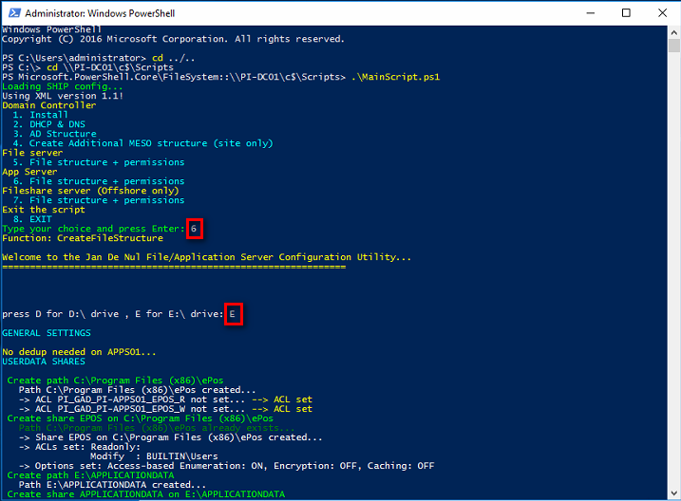

Install the highest version of TeamViewer Host on MGMT01 [\\jdn-file01\Software$\Software - Windows Official\Teamviewer] (accept all popups)

When the TeamViewer entry is added change Name and set the description to the destination folder

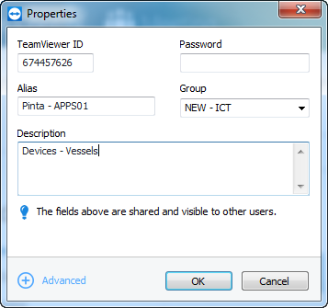

# Deploying FileServer

RDP to XX-FILE01

Start powershell with elevated rights

Navigate to \\XX-DC01\c$\scripts

Execute “.\MainScript.ps1”

Choose D as your drive

